1. Press window key and search ‘Xampp Control panel’
2. Press First 2 start button

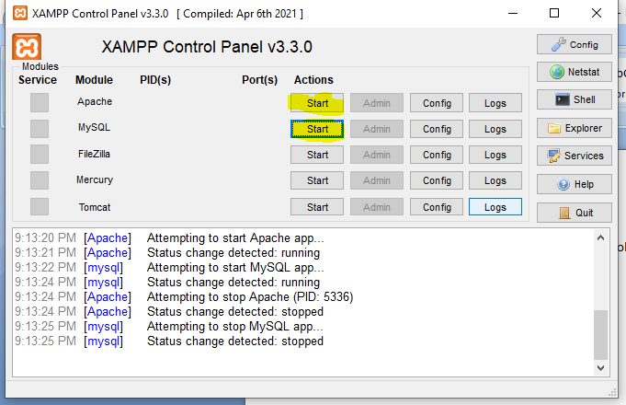

It looks like it’s started

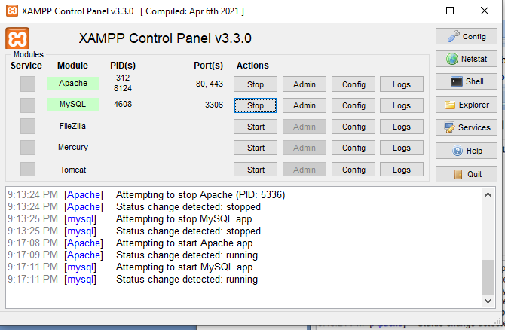

1. The Open eclipse in Desktop

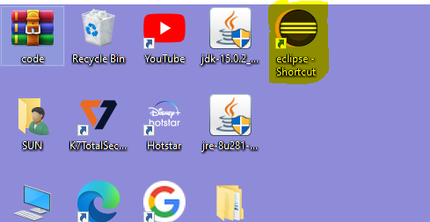

1. Here you can see your projects list

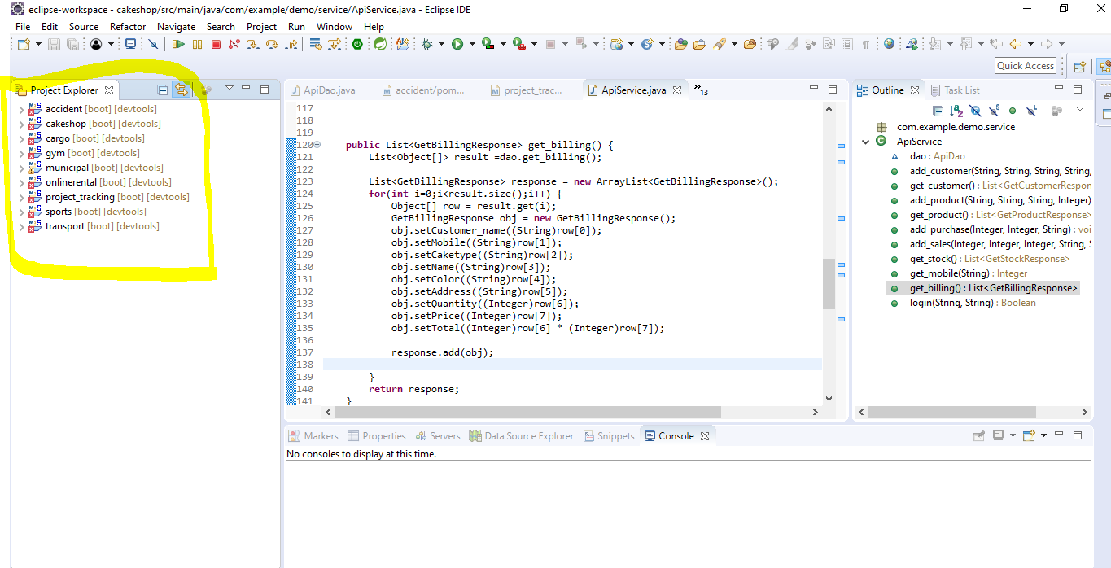

1. Click and Right Click on your project

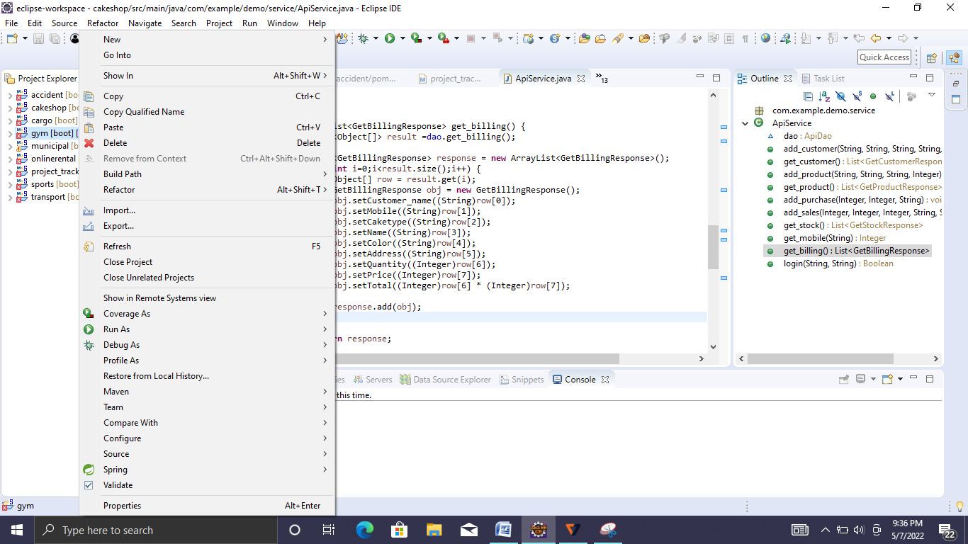

1. Select ‘**Run As**’ and click ‘**Spring boot App**’

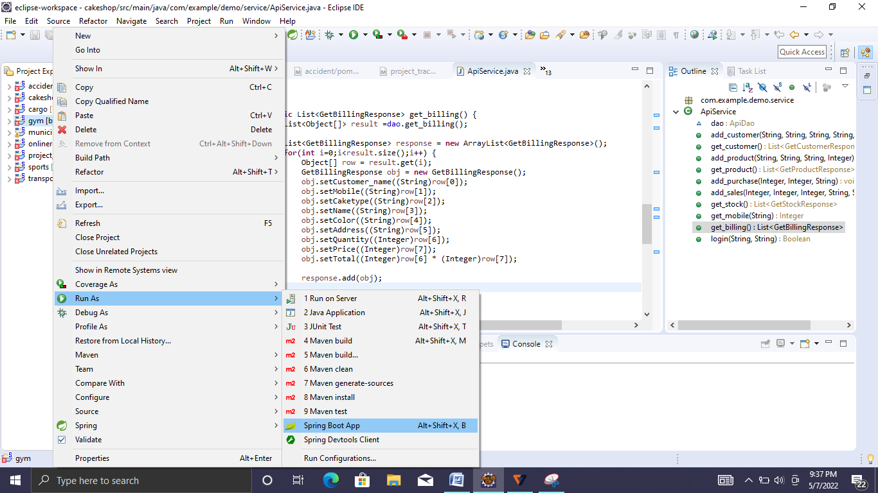

1. Open Firefox or Chrome browser

Open below URL

Accident Record management

<http://localhost/accident>

Cake Shop

<http://localhost/cakeshop>

Cargo management

<http://localhost/cargo>

Gym management

<http://localhost/gym>

Muncipal corporation

<http://localhost/municipal>

Project Tracking

<http://localhost/project>

Online Rental

<http://localhost/rental>

Sports Event

<http://localhost/sports>

Transport management system

<http://localhost/transport>

1. If you want to start next project then close ‘Eclipse’ then open ‘Eclipse’
2. Then follow by Step 4.